1. **Write a short recap of the four tracking steps and what you implemented there (filter, track management, association, camera fusion). Which results did you achieve? Which part of the project was most difficult for you to complete, and why?**

**Summary of filter:**

Purpose: predict state vector and state covariance matrix for each track

1. Initialized with process noise covariance matrix Q and model matrix F
2. Takes raw sensor data, state measurement H(x), sensor matrix H from measurement
3. Takes state X and state covariance matrix P from track object
4. Update state X and state covariance matrix P in track object

**Summary of track management:**

Purpose: manage track list by updating old tracks, creating new tracks, or deleting ghost and old tracks.

1. Initialized with empty track list, last id = -1, number of tracks = 0, and
2. Contain track object first Initialized with prior state X (taken from measurement), prior covariance matrix P, track score, track state and other track attributes
3. Take unassigned track list from association and drop the score of unassigned track
4. Loop through all tracks in the track list and based on track state, track covariance matrix P and track score to decide if the track needs to be deleted
5. Create new tracks based on unassigned measurement list which are not associated to any old tracks

**Summary of association:**

Purpose: match sensor measurement to corresponding track. Then, update unassigned track list and unassigned measurement list

1. Initialized with empty unassigned track list, unassigned measurement list and empty association matrix.
2. Take track list from track management and sensor measurement. Then, associate each track to corresponding measurement and update unassigned track list and unassigned measurement list.

**Summary of camera fusion:**

Purpose: use camera measurement to update state X and state covariance matrix P

**Results achieved:**

Can run multiple objects detection by using both camera and lidar measurements. My test can detect four vehicles and no incorrect detections have been confirmed as object

**The most difficult part:**

To me the most difficult part is track management because it includes multiple checking that leads to many hidden bugs.

1. **Do you see any benefits in camera-lidar fusion compared to lidar-only tracking (in theory and in your concrete results)?**

Yes, I can see clear benefits in camera-lidar fusion. The first picture is lidar-only detection. The second picture is camera-lidar fusion detection. With lidar-only detection, there are only three cars detected and those three tracks all have slightly larger RMS error.

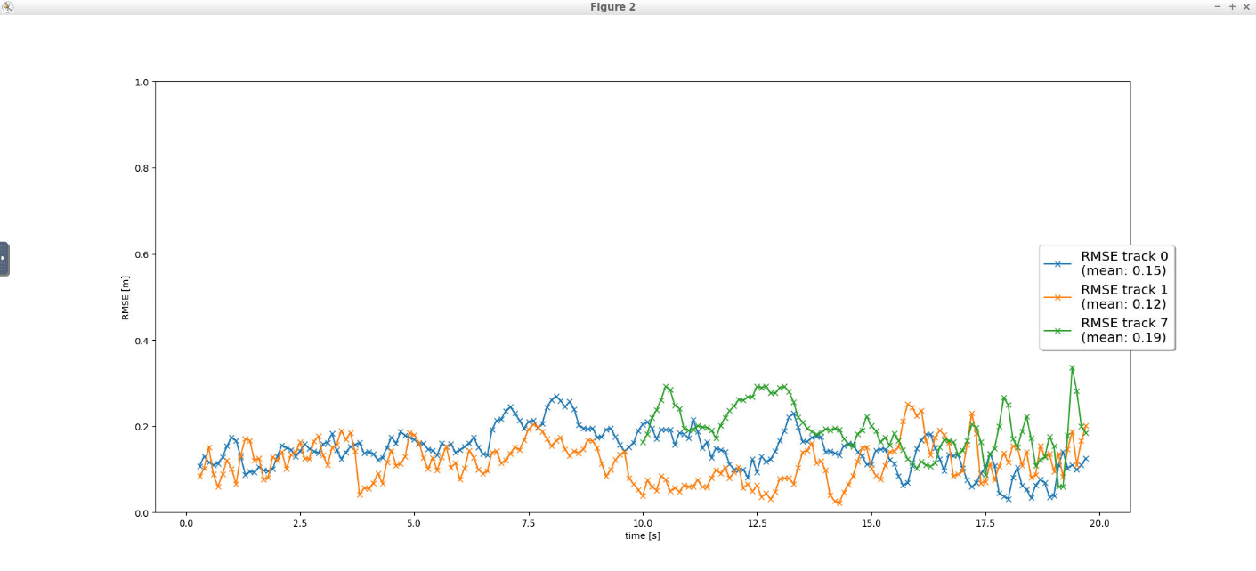

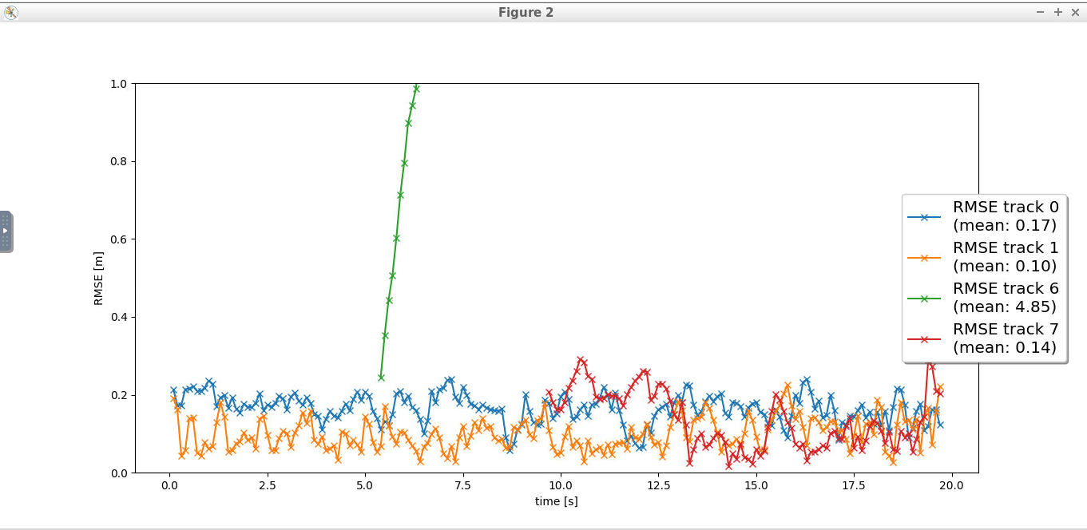

1. **Which challenges will a sensor fusion system face in real-life scenarios? Did you see any of these challenges in the project?**
2. If lidar is noise, there won’t be accurate depth measurements since our camera measurement doesn’t include depth information.
3. Current dynamic model is not accurate enough.
4. My current association method is not accurate enough
5. **Can you think of ways to improve your tracking results in the future?**
6. Include camera depth measurements
7. Change current dynamic model to bicycle model
8. Use better association algorithm such as JPDA and GNN